# INTRODUCTION

This project aims at solidifying the basics of front-end web development among students. Our goal was to make an e-commerce site, a blog, portfolio for each team members and a feed-back form. Working on this project will help us be familiar with the basics of HTML, CSS and JavaScript, which are an integral part of web development.

Our websites name is Origin Bonsai. We have tried our best to make a well-functioning and cohesive website using what we know. It was not easy to put everything together and make the website look good. Every team member had their own ideas and aspirations, to homologate all those different ideas into a website was the most difficult part. But I am confident that our team has done their best and has created a website we all are proud of.

## Goals and objectives

The main goal of this project is to make a e-commerce website with a blog, feed-back page and portfolio using vanilla JavaScript, HTML and CSS. We are not allowed to use any frameworks or libraries. This is to help us learn the fundamentals of how HTML, CSS and JavaScript works before diving into the more advance stuff.

## How HTML, CSS and JS was used

## Verdict

# DISCUSSION AND ANALYSIS

# TESTING

## JavaScript Testing

### Testing Form validation for feed-back Page

Table : Test1: Form Validation

|  |  |
| --- | --- |
| Test No: | 1 |
| Objective: | To Test if form is accepted only when all fields are filled |
| Action: | * Leave one field in feedback form empty * Check if error alert is shown |
| Expected Result: | When form is not filled completely an error alert is shown |
| Actual Result: | Error alert was shown when the form was not filled successfully |
| Conclusion: | The test is successful |

Let’s leave a field empty

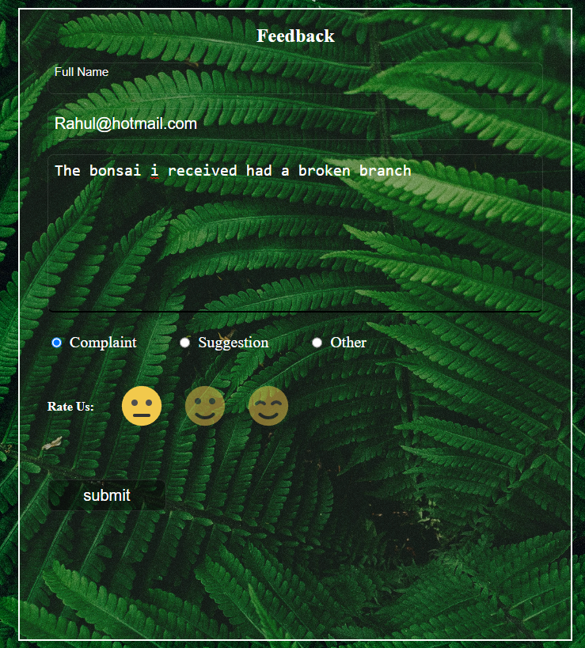

Figure : filling the form

As seen in the figure above, the name field has been left out empty. When we now try to submit this form, an error alert should be shown.

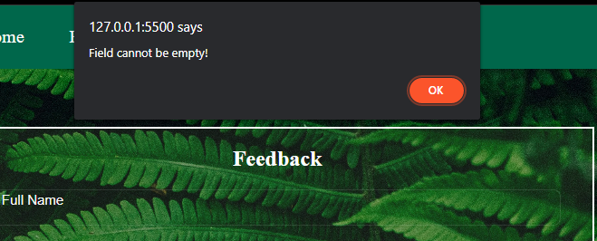

Figure : Error message for incomplete form

So, when we do not completely fill the form an error message is displayed.

### Testing “Rate Us:” emoji rating system

The emoji Rating System works by changing the opacity value of the selected emoji to 1 and the rest to 0.5. JavaScript is used to alter the CSS property of the images.

Table : Test 2: emoji rating

|  |  |
| --- | --- |
| Test No: | 2 |
| Objective: | To check if the emoji selector works |
| Action: | * Select lowest rating * Select middle rating |
| Expected Result: | When a selection is made, other emojis go back to being un-selected. |
| Actual Result: | When a selection was made, other emojis go back to being un-selected |
| Conclusion: | The test is successful |

We can see in the figure below when the lowest rating is selected, the other ratings become opaque automatically.

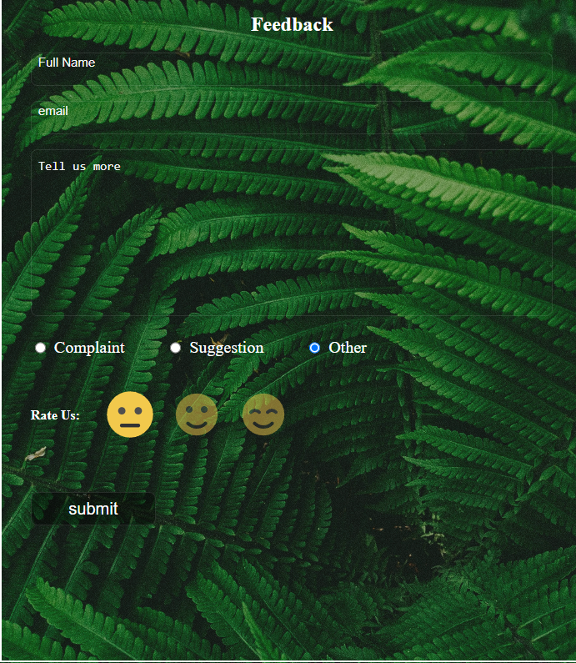

Figure : lowest rating

Accordingly, when we select the middle rating, the lowest rating gets opaque.

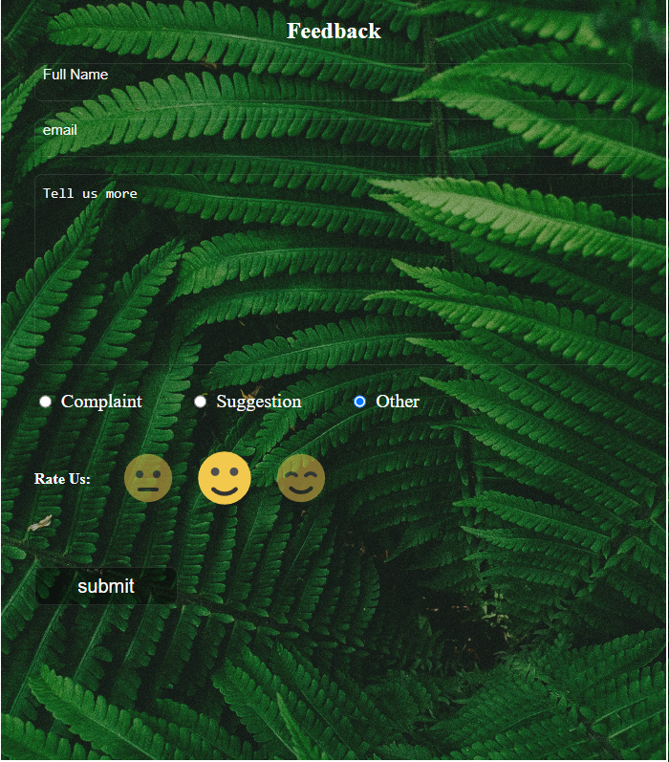

Figure : Middle rating

# CONCLUSION

# APPENDIX